THE HENLEY FORUM 2020 AWARDS
Advancing Practice
Since 2000, The Henley Forum has been dedicated to advancing practice
in developing dynamic organisations
through our programme of research and development.
The Henley Forum 2020 Awards recognise those who are advancing organisational practice. We want to hear from people who are working to develop dynamic capability though knowledge, learning, change and innovation work. For example, by:
enabling knowledge to flow
fostering organisational learning
facilitating organisational change and development
cultivating innovation
and collaborating across boundaries.
These prestigious awards will recognise practitioners who are working to advance organisational knowledge, learning, change and development practice in their organisations.
Awards will be presented at The 20th Annual Henley Forum Conference on 05-06 February 2020.
Award categories
The Henley Forum 2020 Awards recognises those people working to advance practice in 2 categories:
Advancing Knowledge and  Organisational Learning Practice | Advancing Change and  Organisational Development Practice
This award recognises individuals or teams who are working to advance knowledge and organisational learning practice in their organisations | This award recognises individuals or teams who are working to advance change and organisational development practice in their organisation
Chair of Judging Panel: Dr Sharon Varney,  Director in Practice, The Henley Forum  Panellists include:  - Professor Jane McKenzie, The Henley Forum  - Dr Christine van Winkelen, The Henley Forum  - Chris Collison, Knowledgeable Ltd  - Andi McCann, Global Design, Business Architecture and Innovation Lead, HSBC  - Tim Andrews, Stretch Learning  (Communication Specialist) | Chair of Judging Panel: Dr Sharon Varney,  Director in Practice, The Henley Forum  Panellists include:  - Shelly Hossain, Co-Chair, ODN Europe  - Professor Karen Jansen, Henley Business School  - Chris Rodgers, Honorary Senior Visiting Fellow at Cass Business School, City University, London  - Collette Stone, Organisation Development Consultant, HM Revenue & Customs  - Tim Andrews, Stretch Learning  (Communication Specialist)
THE HENLEY FORUM 2020 AWARDS
Advancing Practice

Why enter?
- Learn: The entry process is designed to help you to (1) identify key areas of progress; (2) to highlight the value of your work; and (3) to generate shareable insights that you can use within and beyond your organisation. Use the application process to help you develop the language to gain buy-in to your work. All entrants will receive a summary of feedback from our Expert Panel.

- Share: Shortlisted entrants will have the opportunity to share some of their experience with other practitioners at The 20th Annual Henley Forum Conference. All entrants to The Henley Forum 2020 Awards will benefit from a reduced conference fee.

- Gain recognition: Shortlisted entrants and winners will be featured on The Henley Forum website and on Henley Business School social media platforms.

Key dates
- Entries open on: 01 April 2019
- Entries close on: 31 August 2019
- Shortlisted entries will be announced by: mid October
- Winners will be announced on: 05 February 2020.

Who can apply?
- We would love to hear from our Henley Forum members and beyond
- We encourage entries from around the world
- Entry is open to everyone involved in organisational knowledge, learning, change and development work. You don’t have to have an official role or title in this area. You might be a community manager, or a leader who is actively supporting organisational change and development
- Entry is open to people working in permanent or interim roles
- Each organisation may have multiple entries.

How to enter
- You can put yourself or a team forward, with an endorsement from someone outside the team
- Just complete and return the Entry Form on p5-6 to henleyforum@henley.ac.uk by 31 August 2019
[Information correct as at 20.05.19]
Our Judges
Sharon Varney – Chair of the Judging Panels
Dr Sharon Varney is Director in Practice of The Henley Forum. She is an experienced OD and change practitioner. Sharon has worked in senior management roles in global organisations and now offers thoughtful and practical consulting support to large, complex organisations on leadership and change matters. She is passionate about OD and delivering business change with humanity.
Tim Andrews – Communication Specialist
Tim is the founder of Stretch Learning, an organisation dedicated to bridging the communication and engagement gap between deliverer and receiver… whatever the topic! Tim has been involved in adult learning for the past 30 years, using engaging techniques from a variety of sources. Tim's unique approach to learning stems from what he calls a 'learning difference' in the way he asorbs and translates information.
Chris Collison – Knowledge and Organisational Learning panellist
Chris is an independent management consultant and author with 20 years of experience in knowledge management, facilitation and organisational learning. His corporate experience comes from long careers in BP and Centrica, during which time he wrote the business bestseller Learning to Fly. In 2005 he established Knowledgeable Ltd and has since worked with more than 140 client organisations. His most recent book, ‘The KM Cookbook’ will be published in July 2019.
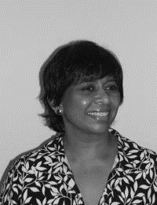 | Shelly Hossain – Organisational Change and Development panellist  Shelly Hossain is co-Chair of ODN Europe and on the Board of the global NTL Institute. Shelly is an Organisational Development consultant and educator. She has spent over twenty years supporting organisations in leadership and change work. Shelly is active in bringing an OD mindset to organisations, and raising the value of OD work in the UK and abroad. She has a passion for social justice and has lead on a number of positive action programmes that have won awards.
Karen Jansen – Organisational Change and Development panellist
Karen is a Professor in Leadership at Henley Business School. Karen is currently exploring how to maintain change engagement across multiple change initiatives simultaneously without leading to change fatigue. Prior to becoming an academic she had a nine-year career at IBM as a systems engineer. Karen has consulted with military, manufacturing, financial, and professional service organisations to navigate large-scale change.
Andi McCann – Knowledge and Organisational Learning panellist
Andi is Global Design, Business Architecture and Innovation Lead at HSBC. He is a business focused change and innovation leader with a commitment to knowledge management, currently introducing a design capability across HSBC globally. Andi has a wealth of experience in financial services.
Jane McKenzie – Knowledge and Organisational Learning panellist
Jane is Professor of Management Knowledge and Learning at Henley Business School. She is a former Director of The Henley Forum (2009-2015) and has contributed to the community since 2000. If you had to describe her interests in one sentence it would be ‘How connections and contradictions affect knowledge work and learning capacity in organisational life’.
Chris Rodgers – Organisational Change and Development panellist
Chris is a consultant, speaker and writer on organizational dynamics. He runs the OD Innovation Network (ODiN) and is Honorary Senior Visiting Fellow at Cass Business School, City University, London. Chris helps managers to get to grips with the real-world complexity of organisational life. Previously he worked as an engineer, and later as a senior manager, in the UK electricity supply industry.
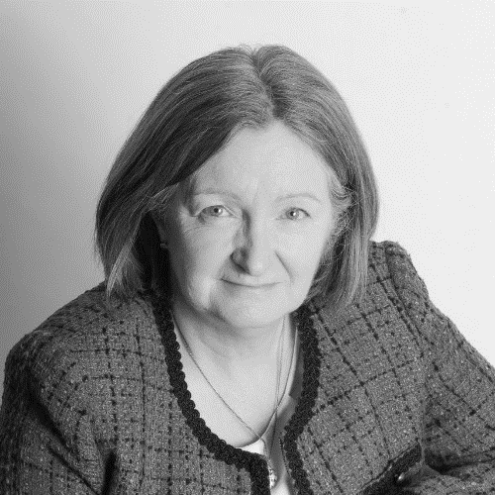 | Collette Stone – Organisational Change and Development panellist  Collette is Organisation Development Consultant to the Executive Committee and top tiers of management at HM Revenue & Customs. She is a progressive transformation expert and executive coach who empowers senior leaders and directors to achieve complex business change and facilitates strong board level strategy. She brings challenge, builds relationships and holds crucial conversations that get to the heart of core issues in business and teams.
Christine van Winkelen – Knowledge and Organisational Learning panellist
Dr Christine van Winkelen is a former Director of The Henley Forum (2004-2009) and has contributed to the community since 2000. Christine has been involved in a number of KM-related research activities. Her focus is on forming a bridge between academic and practitioner aspects of the field. She has published extensively in knowledge management, including two books on Knowledge Management co-authored with Professor Jane McKenzie.

ENTRY FORM
THE HENLEY FORUM 2020 AWARDS
Advancing Practice
Please type your answers below each question (2-10) | For use by judging panel
- Which award are you applying for with this application? (Tick ONE)
Knowledge and Organisational Learning ☐ Change and Organisational Development ☐ BOTH ☐
- Your name, job title, organisation:

- Name of the person or team that you’re nominating (name, function/department, organisation):

- Can you tell us about the work you’ve done? (a, b, c, below):
  - What problem/opportunity were you seeking to address? (max 100 words)

  - What did you do? (max 100 words)

  - Why did you approach it that way? (max 100 words)

- What’s particularly innovative or inspiring about this work? (max 100 words)

- In what ways has this work helped to advance practice in your organisation? (max 100 words)

- What’s the emerging impact of this work for those affected? (max 100 words)

- What are the emerging benefits of this work for the organisation? (max 100 words)

- What’s your emerging learning from this work? (max 100 words)

- Endorsement: Can you please provide name, job title and email address for someone outside your team who can provide a short endorsement of this work?
(We’ll email them a copy of this application and will ask them to provide a short endorsement – max 100 words)

For use by judging panel
Overall comments:

We’ll ask you for permission first

